POSITION DESCRIPTION |  |  |  | 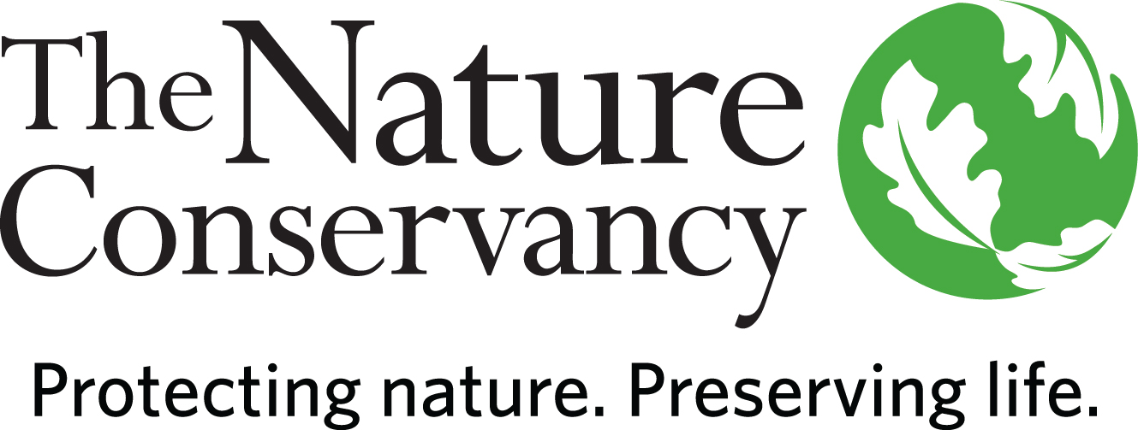
POSITION TITLE | Applied Scientist
JOB TITLE | Applied Scientist III (ICR)
JOB FAMILY | Science
JOB NUMBER | 400007
SALARY GRADE | 8
STATUS | Salaried
DATE | June 2017
LOCATION | Coral Gables, FL preferred. Santo Domingo, Dominican Republic; Kingston, Jamaica; and St. George’s, Grenada also considered.
ABOUT US | The Nature Conservancy is the leading conservation organization working to make a positive impact  around the world in more than 69 countries, all 50 United States, and your backyard.  Founded in 1951, the mission of The Nature Conservancy is to conserve the lands and waters on which  all life depends. One of our core values is our commitment to diversity. Therefore, we are committed to  a globally diverse and culturally competent workforce. Visit www.nature.org to learn more.
SUMMARY | The Applied Scientist provides technical and scientific support and leadership for conservation initiatives in the Caribbean Division, including multiple objective planning and priority setting. S/he will support priorities across the Division, dedicating approximately 50% of his/her time to the Caribbean’s Resilient Islands Program.
ABOUT THE RESILIENT ISLANDS PROGRAM | The Nature Conservancy has been awarded a €5 million grant to carry out the Resilient Islands (RI)  Program (within The Nature Conservancy’s Caribbean Division. The overall objective of the RI Program:  Integrating Ecosystem- and Community-based Approaches to Enhance Climate Change Adaptation in the  Caribbean. This program will focus activities to assist governments and communities in Grenada,  Dominican Republic and Jamaica to incorporate ecosystem-based adaptation in their local-, national-  and regional-scale decisions to prioritize and invest in approaches to reduce vulnerability and boost  adaptive capacity to Climate Change. The outcomes of this effort will benefit up to tens of thousands of  people by identifying priority areas for locally-tailored ecosystem- and community-based interventions  (e.g., mangrove planting), implementing these interventions in 1-3 vulnerable communities per country  and building coalitions of stakeholders at the regional scale to help direct funding for ecosystem  based adaptation to the region.
ESSENTIAL  FUNCTIONS | Under the direction of the Caribbean Division’s Director of Climate Adaptation the Applied Scientist will collect, manage and synthesize data on nature and people. The Applied Scientist conducts scientific surveys and research, collates and, where appropriate, collects data, writes reports and develops proposals in order to develop, manage and oversee projects within the Caribbean Division. In support of the Resilient Islands Program, s/he will develop methodologies to effectively represent socio-ecological systems and help communicate and analyze complex ecological and socioeconomic patterns. S/he will prioritize areas for conservation, support the development of spatial information synthesis and mapping techniques, and collaborates with other scientists and institutions to enhance Conservancy practices.
RESPONSIBILITIES & SCOPE | The Applied Scientist will work closely with the Climate Adaption Director in the overall management  and coordination of the RI science program, focused on developing tools and methodologies to examine role that natural assets (e.g. habitats) play in reducing social vulnerability and risks from natural disasters and climate change. S/he will serve as main point of contact for program leadership (Director of Climate Adaptation and Project manager) on science implementation for the RI project and will collaborate with a cross functional team. S/he will proactively facilitate communication within the RI science team and serve as a member of the RI project management team. The Applied Scientist will support proposal and grant writing, as well as develop and manage contracts. S/he will travel frequently to project sites and help design and facilitate workshops with partners and help collect new information. The Applied scientist will also support Divisional activities that relate to conservation planning, priority setting and spatial analysis. S/he must be a team player and have willingness to support a wide range of tasks.
MINIMUM QUALIFICATIONS | - Master's Degree in science related field and 4 years of experience or equivalent combination of education and experience  - Experience leading and/or supporting peer reviewed publications in scientific journals  - Experience manipulating, analyzing and synthesizing socio-economic and ecological data  - Proficient in Geographic Information Systems  - Experience fundraising and/or writing grants and research proposals  - Experience leading or participating on cross functional teams  - Experience managing complex projects including the financial aspect and coordinating the work of peers and partners  - Experience working and communicating with a wide range of people including geographically distant teams
PREFERRED KNOWLEDGE, SKILLS & EXPERIENCE | - Multi-language skills and multi-cultural or cross cultural experience appreciated. Fluency in Spanish is a plus  - Strong computing skills  - Knowledge of Ecosystem Based Adaptation Strategies and Climate adaptation  - Management of large spatial data-bases  • Experience working with humanitarian organizations  - PhD and 1-3 experience considered  - Experience organizing and facilitating workshops  - Proven negotiation skills  - Attention to detail  - Training experience
ORGANIZATIONAL COMPETENCIES | Communications | Effectively expresses messages verbally and in writing. Actively listens to others. Fosters open exchange of issues. Is timely with information.
 | Flexibility & Innovation | Flexible to changing circumstances. Takes innovative approaches towards work. Takes calculated risks and makes dependable decisions in the face of uncertainty.
 | Interpersonal Savvy | Maintains positive working relationships. Contributes to productive partnerships inside and outside the organization. Understands team member roles and values the contributions of others. Effectively deals with conflict.
 | Open to Learning | Versatile learner and committed to self-improvement. Employs strengths effectively. Willingly shares knowledge with others. Seeks coaching on areas needing improvement. Adjusts behavior/performance as needed. Views mistakes as learning opportunities.
 | Organizational Awareness | Understands the basics of our business. Knows how local job relates to the big picture & contributes to the overall strategy. Knows how/why things work inside TNC. Easily moves through internal networks and channels for success.
 | Produces Results | Takes Initiative. Focuses on priorities. Strives for excellence. Is dependable and accountable for results. Persistent in the face of obstacles and meets deadlines.
This description is not designed to be a complete list of all duties and responsibilities required for this job.

HOW TO APPLY:
Visit www.nature.org and apply online to job# 45540. All resumes and cover letters must be submitted through The Nature Conservancy’s online application system. Please upload them into your application as a single document. The application deadline is 11:59pm EST July 7, 2017.

If you experience technical problems with the site or application process, please contact applyhelp@tnc.org and include the job opening ID. Please do not send questions related to specific positions to this e-mail address as they will not be able to be answered.

The Nature Conservancy is an Equal Opportunity Employer. Our commitment to diversity includes the recognition that our conservation mission is best advanced by the leadership and contributions of men and women of diverse backgrounds, beliefs and cultures. Recruiting and mentoring staff to create an inclusive organization that reflects our global character is a priority and we encourage applicants from all cultures, races, colors, religions, sexes, national or regional origins, ages, disability status, sexual orientations, gender identities, military or veteran status or other status protected by law.

