**Frequently Asked Questions related to Promotion and Tenure Workflow System**

*Updated 5/10/2023*

1. **How do I Log in?**

**Open Workflow System –** As a candidate for Promotion and Tenure and as a reviewer, you will receive an email from Digital Measures by Watermark <dmworkflow@watermarkinsights.com> as shown below, to submit materials or initiate your review. Click the **Open Now** box to be taken to the Digital Measures sign in screen.

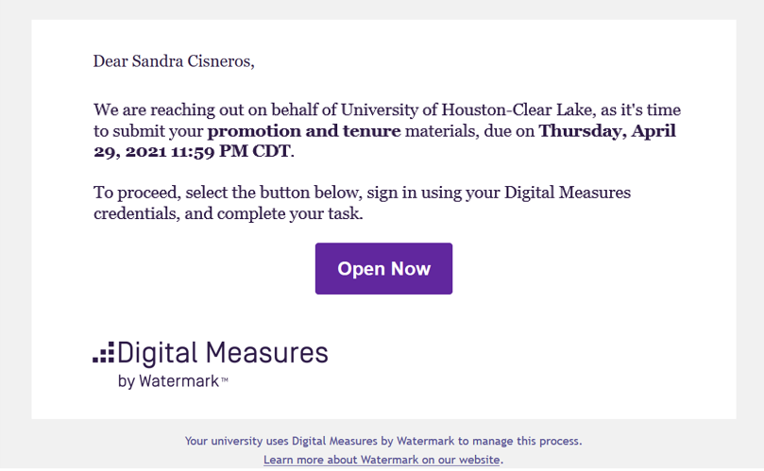

**Sign In –** Sign in using your UHCL Credentials.   
   
 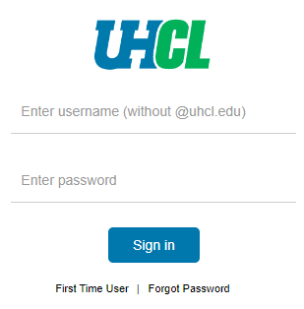

**Authenticate your credentials using DUO –** Authenticate your credentials via text, phone call, or passcode (shown below)

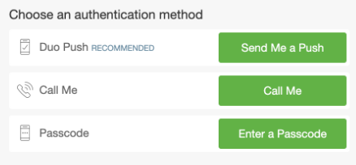

**Select the Digital Measures App** (shown below)

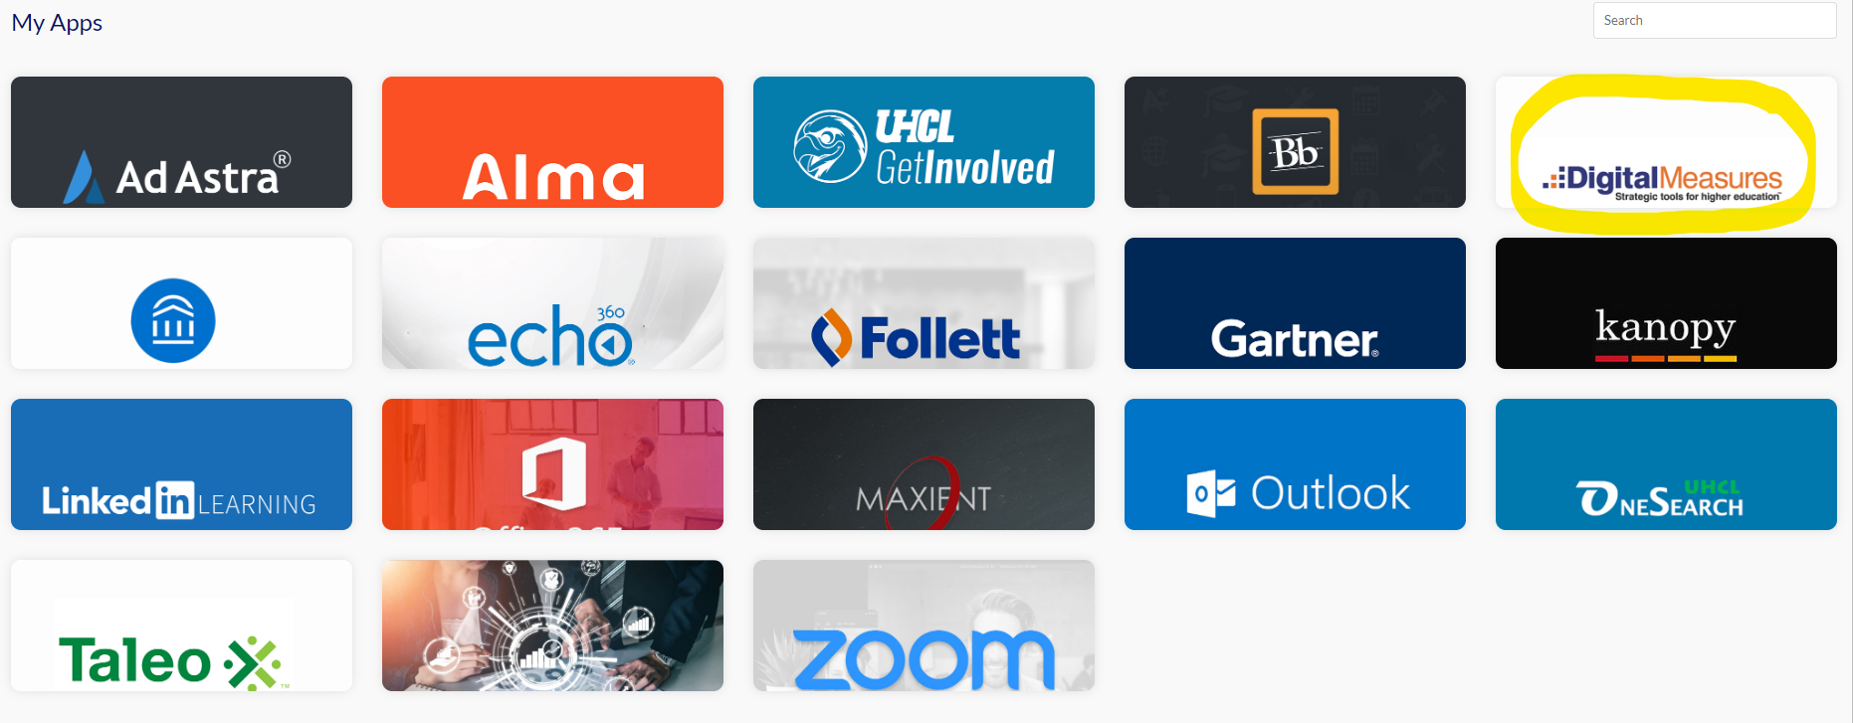

**OR Sign in directly** through the [Promotion and Tenure](https://www.uhcl.edu/provost/faculty-staff-resources/faculty-resources/promotion-tenure) website, without using your email.

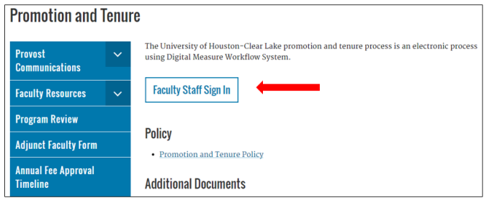

Use the Faculty Staff Sign In button to sign in using your UHCL credentials.

1. **Will changes I make in Digital Measures Faculty Activity be automatically changed in Workflow?**

No. If you need materials from your Digital Measures activity area, you will need to create a new file (generate a report) from Digital Measures and then upload it to Workflow.

1. **After clicking "Submit" to move a process to the next step, will I be able to edit information I already provided in the form?**

Please email [workflow@uhcl.edu](mailto:workflow@uhcl.edu) if you have submitted something in error prior to submission deadline and it will be determined if the materials are able to be returned to you.

1. **What happens when I miss a due date?**

All materials auto advance at midnight **on the date** of the deadline specified in the [Promotion and Tenure Timeline](https://www.uhcl.edu/provost/faculty-staff-resources/documents/promotion-and-tenure-timeline-2023-2024.pdf) for the year you are going up as a candidate.

1. **What types of files can I upload to Workflow?**

Workflow will accept any type of file (docx, PDF, xlsx, mp3, and more). Files must be maximum 1 GB or less. **Do not upload PDF Portfolio Files.** These are a specific kind of PDF file that the workflow system is not able to ‘read.’ While a candidate can technically upload them, they cannot be read or viewed by reviewers. Again, a regular PDF file is acceptable, a PDF Portfolio **should not** be used.

1. **Whom do I contact for help?**

If you have questions about the promotion and tenure process, contact your department chair or Academic Associate. If you have technical questions about Workflow, contact Renee Chavez, Faculty Affairs Coordinator in the Office of the Provost via [workflow@uhcl.edu](mailto:workflow@uhcl.edu). If you have login questions, make sure you are using the 2-factor authentication, then if there are still problems, contact OIT support at ext. 2828 **and** notify Renee Chavez at [workflow@uhcl.edu](mailto:workflow@uhcl.edu).

1. **What is the Candidate’s Review Statement?**

It is a formal request for promotion and/or tenure in the university. A template of the document can be found on the Office of the Provost’s website under “Additional Documents”, [here](https://www.uhcl.edu/provost/faculty-staff-resources/faculty-resources/promotion-tenure). Please download, update, and use this document as your Candidate Review Statement.

1. **Where do I find my applicable promotion and tenure criteria?**

It’s can be found on the Office of the Provost’s website under “Additional Documents,” [here](https://www.uhcl.edu/provost/faculty-staff-resources/faculty-resources/promotion-tenure).

1. **What are written notifications of probationary period extensions?**

If you have been approved for extensions on your P&T clock, provide the written notifications you received from the Dean or Provost.

1. **What information should I include in my narrative?**

In your narrative, you make your case for promotion and/or tenure. Organize your material under the three categories of professorial responsibility: (1) Teaching and Educational Activities, (2) Research, Scholarly, or Artistic Activities, and (3) Service. Your entire narrative may total no more than the lesser of 7,500 words or fifteen pages.

1. **What type of material should I include in my appendix?**

Provide supporting materials that spotlight your productivity and achievement in the three areas of professorial responsibility: (1) Teaching and Educational Activities, (2) Research, Scholarly, or Artistic Activities, and (3) Service. Examples could be teaching evaluations, course summaries, published research, research summaries, artistic products, and more.