https://www.nrcs.usda.gov/wps/portal/nrcs/detail/soils/survey/tools/?cid=nrcs142p2_054167
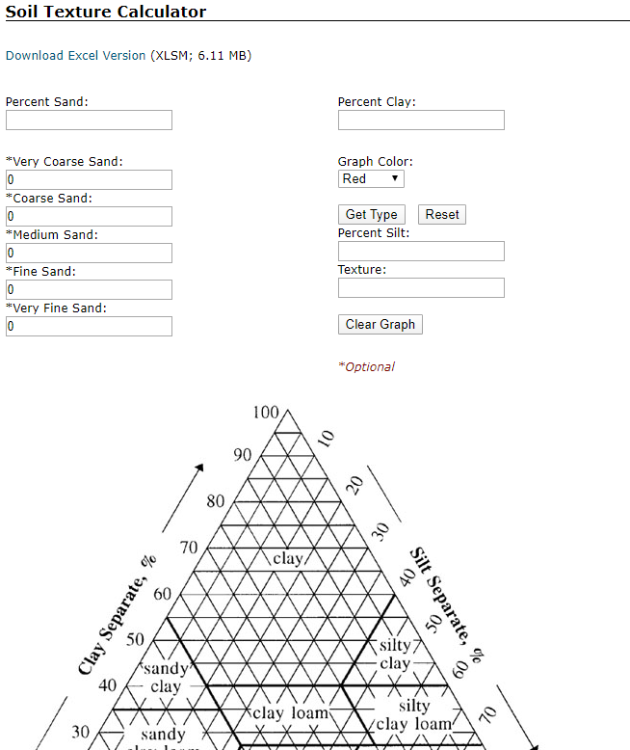
https://casoilresource.lawr.ucdavis.edu/soilweb-apps/

