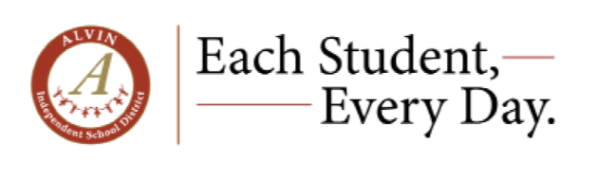
ALVIN ISD Observation Procedures and Guidelines

Classroom Observations and Field Experiences will be scheduled September - March each school year for students/interns seeking observation hours or field experience to meet TEA course/program requirements.
Process For Approval to OBSERVE in ALVIN ISD
- Review the ALVIN ISD Observation/Field Experience Procedures and Guidelines below.
- Complete: ALVIN ISD OBSERVATION HOUR REQUEST FORM when available.
- When approved, an HR representative will send you a GENERAL INFORMATION SHEET and CONSENT for BACKGROUND CHECK to complete.
Process For Approval for FIELD EXPERIENCE in Alvin ISD
- Review the Alvin ISD Observation/Field Experience Procedures and Guidelines below.
- Students Complete: ALVIN ISD FIELD EXPERIENCE REQUEST FORM when available.
- University Professors or the School of Education office staff communicate by email with Natalie Hoskins at nhoskins@alvinisd.net to request FE placement in Alvin ISD after filling out Field Experience Request Form.
- Placement requests must include a list of student names, content & grade level preference, and a date range for students to participate. Human Resources will select the campus. Placement requests must be made three weeks before students begin on campus.
- An HR representative will send the student a GENERAL INFORMATION SHEET and CONSENT for BACKGROUND CHECK to complete.
- Once approved, professors, campus administrators, and administrative assistants will receive communication from Natalie Hoskins with all placement details and a list of student names and dates of participation on campus.
PLEASE NOTE:
- Fall observations/field experiences begin after the 2nd week in September and end the last week of November.
- Fall observation/field experiences requests will not be considered after the first week of November.
- Spring observations/field experiences begin after the 3rd week in January and end the last week of March.
- Spring observation/field experience requests will not be considered after the first week of March.
- Number of hours allowed is determined by district and campus schedules.
- Applicants are processed in date order after completing all steps above.

OBSERVATION AND FIELD EXPERIENCE GUIDELINES:
- It will typically take a minimum of 10 days to process your request to complete observation hours.
- All cell phone use for any purpose during observations is prohibited.
- Professional dress is required for all observers.
- Please ensure that you have your photo ID to be scanned in using the campus Raptor System. You will be printed a visitor badge. Please ensure your badge is worn in an area that is visible to all staff and students. You will NOT be permitted in the building if you do not present a photo ID to be scanned - there will be no exceptions.
- Remember that all information concerning students is confidential.
- You may not observe in your child's classroom.
- The campus administrator has the authority to deny or discontinue requests for observation hours.
- Approved observation time frames are by semester and do not extend into another semester.
