Student Media
SFAC BUDGET REQUEST QUESTIONNAIRE – Budget Cycle FY27

Instructions: For each question/statement below, provide a clear and concise response (4 to 7 sentences). Note the special instructions for the following questions:
- For Question #2, attach/include an updated organizational chart for your unit with this document OR embed it in your response below.
- For Question #3, attach/include your Budget Worksheet AND provide a short list of funding sources, their intended purpose, and how you are utilizing the funds.

Questions and Statements
- Provide a summary of your unit’s mission/purpose, how you accomplish your unit’s mission or purpose, and a justification of your unit’s student fee allocation in terms of the benefit to students.
The mission of the University of Houston-Clear Lake (UHCL) Student Media is to amplify student-driven expression, innovative storytelling, and impactful journalism. We strive to inform, educate, and engage the UHCL campus and surrounding communities through journalistic best practices. UHCL Student Media serves as a professional learning environment where students can gain valuable skills and experiences across various media channels.

Student Media accomplishes our mission through professional and hands-on training, such as:
- Content Creation: Produce real-time, factual, and expressive content through articles, podcasts, videos, photos and social media.
- Journalism Reporting: Writing that highlights campus, community and national events with accuracy and relevant information.
- Workshops and Training: Offer training sessions and workshops on media ethics, writing, editing, multimedia production and social media marketing to enhance student skills.
- Community Engagement: Engage with the UHCL campus and surrounding community to broaden the informational reach and create collaborative projects.
- Digital Presence: Maintain a strong online presence through social media and a website to reach a broader audience.
- Professional Experience: Provide a comprehensive space for students of all majors to build professional communication skills.
- Preservation: Keep a comprehensive archive of published work for historical reference and student expression at UHCL.

Student Media uses its funding to retain accessibility to professional development and creative expression for our students. The allocation of fees supports the four key benefits of:

- Empowerment and Freedom of Expression: Student Media amplify student voices and creative expression through the First Amendment
- Professional Development: The investment in Student Media, gives additional access to hands-on experience for their future careers. This practical experience allows our students to be competitive in a global job market.
- Civic Engagement: Our coverage of campus and community engages students in being informed while promoting a campus-wide culture of awareness.
- Enhance Campus Culture: Student Media contributes to a robust campus atmosphere by highlighting achievements, events and important conversations.

- Provide an organizational chart of your unit. Include all professional and student staff positions (with names), as well as vacancies. Make sure it is easily identifiable between professional and student staff on the chart.
(August 2024 – May 2025)
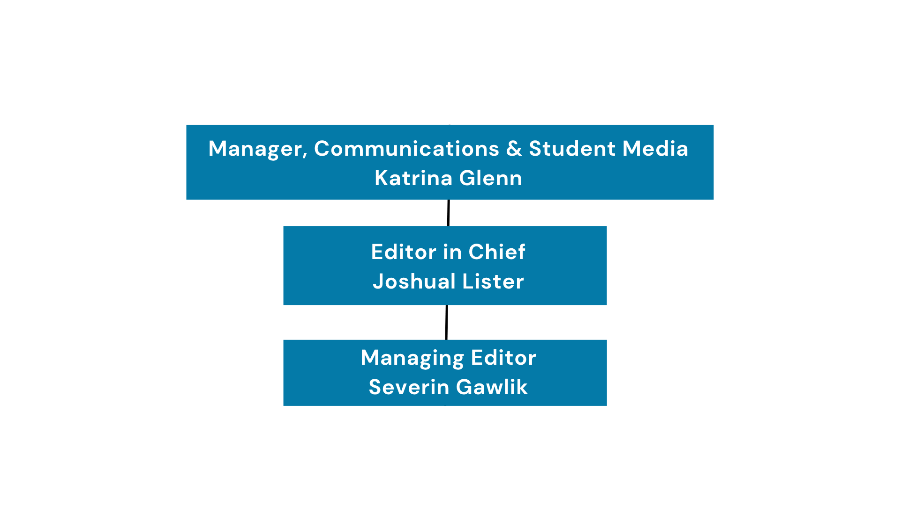
Professional Staff
- Katrina Glenn, Manager, Communications & Student Media

Contractor Staff (The Signal) (August 2024 – May 2025)
- Joshual Lister, Student Editor-in-Chief
- Severin Gawlik, Student Managing Editor

(June 2025 – August 2025)
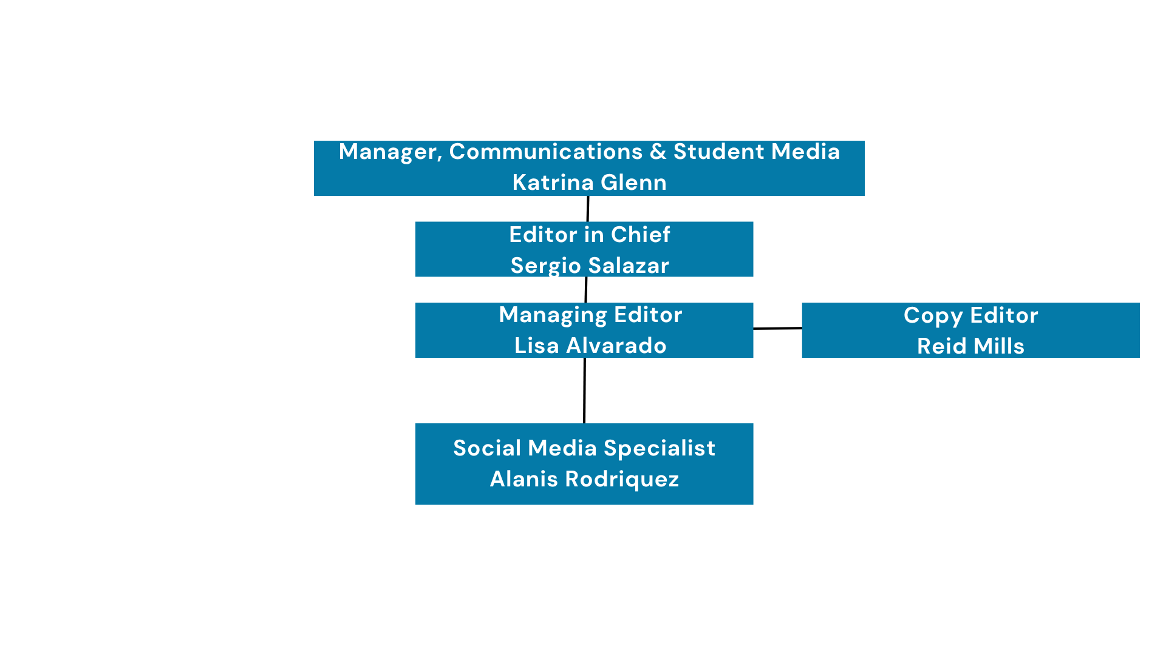

Professional Staff
- Katrina Glenn, Manager, Communications & Student Media

Contractor Staff (The Signal) (June 2025 – August 2025)
- Sergio Salazar, Student Editor-in-Chief
- Lisa Alvarado, Student Managing Editor
- Reid Mills, Student Copy Editor
- Alanis Rodriguez, Student Social Media Specialist

- Present your Budget Worksheet. You are required to show and outline ALL funding sources (i.e. student fees, central funding, grants, gifts, outside sales revenue, auxiliary income, etc.). Use this area to define each funding source, its intended purpose, and how you are utilizing said funds.

See Attachment

Student Media receives funding through several sources to support student development offered through the department in line with our mission. This includes funding from Student Service Fees (Designated and One-Time requests) funds.
Designated Funds:
- $88,304: Professional Employee Salaries and Fringe Benefits
- $48,872: Student Media office operations and Travel. This allocation allows us to efficiently operate the office through the purchase of computers, printers, office supplies, etc. It also pays our student contractors, who are our editors and specialists. Travel for Staff and Students to attend professional development conferences and award competitions.

- Did you receive any new funding for FY25? If so, please explain how it is being used. If you received any new one-time funding for FY26, please describe your plans to use those funds.
Student Media received a one-time request of $15,000. Out of the $15,000, $8,449.97 was used to purchase new camera equipment. Initially, $12,679.27 of equipment was ordered; however, $4,229.30 of the total was comprised of backordered items.
Student Media did not receive new base funding for the fiscal year 2025.
Student Media did not receive a one-time request or new base funding for the fiscal year 2026.

- How does your unit support the mission of Student Affairs and contribute to the student experience on campus? Consider the utilization and impact of your unit’s services.
The Division of Student Affairs creates transformational experiences that strengthen the educational journey for UHCL students. Student Media aligns with DSA’s mission by focusing on developing the students’ professional skillsets and amplifying their voices. Students actively engage through the campus publication, The Signal. This student media outlet functions as an area where students build and practice the following skills:

- Writing
- Copyediting
- Photography
- Digital Design
- Business Management
- Marketing
- Video and audio production
- Journalism reporting
- Community building
- Leadership

- What did you learn in your annual assessment that is impacting your programs and services now?

The following points were learned from the FY25 annual assessment that is impacting Student Media are:

- With the 550% increase in recruitment and the 150% increase in retention, Student Media is growing in a rate where more students are getting involved in student driven express and hand-on skill development.
- After a semester of involvement within Student Media, our data showed that 85% or more of the students who completed our post skill survey move up at least one proficiency level in six communication skill areas.
- 100% of students reported that they felt confident after their contract period with Student Media.
- The Signal, housed under Student Media, saw a 7315.26% increase in viewership. The original Signal website was compromised, leaving the publication to create and market a new website.

- Describe any new programs and/or initiatives for the current year.

New initiatives for Student Media:
- Podcasting, an expansion of communications focus areas.
New positions within Student Media:
- Copy Editor
- Social Media Specialist
- Multimedia Specialist
- Photographer

- What challenges or opportunities do you foresee for the current year and next year?
Challenges:
- Staffing/ Beat Editors: As The Signal continues to grow, one of the foreseeable challenges is the number of editors on staff. Editors play a critical role in maintaining the quality, accuracy, and consistency of the publication. Without enough editors, it becomes increasingly complex to manage the expanding workload—from reviewing articles and fact-checking to coordinating deadlines and supporting writers. This shortage can lead to delays in publication, increased stress on existing staff, and missed opportunities for in-depth coverage. It can also limit the paper’s ability to innovate or grow its digital presence. A small editorial team reduces opportunities for mentorship and peer development, which are essential for building a sustainable and skilled student-run newsroom.
Opportunities:
- Expanding Student Media: This year, the Manager of Communications & Student Media and the editorial team are creating the opportunity to expand The Signal to include journalism in the form of multimedia (video and photojournalism). Expanding the communication focus areas will allow students from all majors to engage in digital storytelling and broaden their technical skillset actively.
- Establishing a Formal Faculty Advisory Board: Creating a faculty advisory board for the collegiate newspaper presents a strategic opportunity to strengthen the program both academically and operationally. A dedicated board made up of faculty members from diverse departments, such as journalism, communications, business, and design, can provide valuable guidance, mentorship, and institutional support to the student-led publication. This board can help ensure journalistic integrity, provide feedback on content and ethical standards, and serve as a bridge between the newspaper and the broader goals of the college. Faculty members can also assist in aligning the publication with curriculum goals, offering insights on industry trends, and helping students connect classroom learning with practical newsroom experience.
- Advertisement: Introducing advertising into The Signal presents a valuable opportunity for both the publication and Student Media. By opening ad space to local businesses, campus departments, and potential underwriters, the newspaper can generate a sustainable sponsorship or revenue stream. This financial support can be reinvested into hiring additional student contractors, expanding distribution, or enhancing our digital content. Beyond finances, managing advertisements gives students real-world experience in media sales, marketing, client relations, and business operations, skills highly applicable in today’s communications and journalism careers. It also fosters connections between The Signal and the surrounding local area, increasing visibility and engagement. Ultimately, integrating advertising aligns with the program’s goals of promoting student development, professional readiness, and long-term viability of student-led media.

- Did you have more than $5,000.00 in Student Fee funds swept at the end of FY25? If so, describe how much and in which areas the funds came from.

Student Media swept $66,029.00. The funds were taken from the Maintenance and Operations and Travel budget lines. Student Media underspent a significant portion of its Maintenance and Operations budget, primarily due to the rebuilding and reactivation phase of The Signal.

At the beginning of the FY25, The Signal had minimal presence and engagement on campus. As a result, efforts were first focused on reestablishing the outlet’s foundation, increasing visibility, and rebuilding internal operations. This included strategically setting up the infrastructure necessary to support student contractors. Because this rebuilding process took most of the academic year, Student Media was unable to recruit or hire paid student contractors until April 2025. The delay in onboarding paid student contractors resulted in a significant portion of the student staffing budget going unused.

Additionally, Student Media did not attend the College Media Convention in the fall and did not replace the backordered items from the one-time funding.

- Are you requesting any new one-time funding for FY26 or FY27? Present your budget request with appropriate justification. *Note that only one-time funding requests (no base requests) will be reviewed for FY26 and FY27.

- FY26 - $8,200
  - $2,700 – Podcasting Equipment

We are asking for $2,700 to purchase podcasting equipment. With the expansion of The Signal’s online multimedia presence, including forays into regular podcast production, having sufficient funds to purchase quality audio processing equipment for the facilitation of in-house podcast production. In Fall 2025, The Signal partnered with the Podcasting course taught by Professor Michael Brims, where students received training on industry-standard equipment. Building on this collaboration, we aim to equip our newsroom with the same audio gear used in the university’s Communications program. This alignment not only ensures continuity in students’ learning experiences but also provides them with access to professional-grade tools that reflect real-world media production environments. Investing in this equipment will give students hands-on opportunities to develop and refine their audio production skills outside the classroom, enhance the quality of our multimedia content, and strengthen The Signal’s role as a platform for student storytelling and expression.

  - $3,500 – Two Outreach Student Contractors tasked with building internal/external connections
We are requesting $3,500 to hire two outreach student contractors who will be paid $350 a month for 12 hours a week. They will be responsible for developing and strengthening both internal and external connections for The Signal. This investment is critical to the long-term sustainability and visibility of our student media program. Currently, our organization lacks the dedicated capacity to proactively develop partnerships within the university and the surrounding community that are essential for growth, resource-sharing, and audience engagement. These student contractors will focus on strategic outreach to academic departments, business, local media, and community stakeholders to establish pipelines for collaboration and cross-promotion.
The initial outreach work requires focused, intentional, and consistent effort that current student contractors, who are already balancing editorial and production responsibilities, simply cannot provide. Once these internal and external connections are established, the continuity plan phase for contracting an advertising specialist will absorb the duties of the outreach contractor.
This one-time funding will enable us to scale The Signal’s presence and impact in ways that will benefit the publication, increase engagement, advance our continuity plan, and amplify student voices for years to come.

  - $2,000 – Signal Promotional Items for tabling and campus/community outreach events
We are requesting $2,000 in one-time funding to support the ordering and distribution of promotional materials that will enhance The Signal’s visibility and outreach on campus and in the surrounding community. With the upcoming launch of our newly designed logo, this funding will allow us to produce updated merchandise and promotional items that reflect our refreshed identity and help reinforce brand recognition. As The Signal continues to expand its presence at university-sponsored and community events, having a consistent, professional visual identity is essential for increasing awareness, attracting new readers and contributors, and strengthening our reputation as a central platform for student journalism.
Additionally, providing our editorial team with branded polos or t-shirts for tabling and event participation will ensure they are easily identifiable and present a unified, professional appearance. This visibility not only promotes The Signal but also enhances our engagement efforts by inviting interaction and building trust with students, faculty, and community members.
Because these materials are tied to a long-term rebranding effort, this is an investment that will lay the groundwork for more effective outreach and public engagement that is currently nonexistent.

- FY27 - $27,700
  - $12,600– Two Outreach Student Contractors tasked with the establishment of a Consistent and Self-Sustaining Advertising Infrastructure
We are seeking $12,600 to contract two students at $525 per month for 15 hours of work per week. These students will build a consistent and self-sustaining advertising infrastructure, outreach, and ad campaign sales. Advertising sales are an essential facet of revenue for any publication. Advertising revenue can aid in contracting additional students to structure a traditional and robust newsroom/media business. Currently, there can be no increase in the number of contracted team members (of which the current setup only covers the bare necessities to run at our present, diminished scale) within the current operating budget.

As shared in our goals, by bringing advertising in-house and not outsourcing it to an agency, students can gain real-world experience in media sales, marketing, client relations, and business operations skills highly applicable in today’s communications and journalism careers. Integrating advertising aligns with the program’s goals of promoting student development, professional readiness, and long-term viability of student-led media.

  - $1,200 – Mailchimp
The Signal is asking for $1,200 to purchase a one-year subscription to Mailchimp. The need to establish an external newsletter and a space for ad sales would require the use of a third-party newsletter distribution service. Mailchimp is a widely used, reputable newsletter distribution platform that is initially free, but requires routine payments to utilize its services after a certain threshold of subscribers has been attained. The amount will allow us to reach 5,000 subscribers and align ourselves with publications standards of outbound outreach. With the revenue of ads and base funding, The Signal will be able to sustain the yearly cost of the Mailchimp platform for FY28.

  - $2,500 – Printing Budget of Newspaper
We are asking for $2,500 to establish physically newspaper printing. A staple of every well-established student publication is a physical, printed copy of the “paper” that other students, staff, and faculty can hold, read, and share between each other in-and-around campus.
The first step would be to initially print “special editions” themed around certain events taking place on campus before potentially moving on to a more regular printing schedule.
The printing of The Signal is something that has not been done by the publication in the last five or six years. With the fact that printing has become more expensive in recent years, this one-time ask would supplement the printing of multiple editions that could not be afforded by our base budget. In the future, to supplement the cost of printing would be through ad revenue.

  - $8,400 – Fall National College Media Convention
The Signal is seeking $8,400 to support four or five students and one advisor in traveling to the CMA National Convention. The Fall College Media Association (CMA) “MediaFest” is a national annual event that brings college publications from around the entire country into one 4-day long professional media/journalism development conference.
Offering a variety of workshops put on by renowned professionals in their respective fields (including representatives from the Society of Professional Journalists (SPJ), the Student Press Law Center (SPLC) and Senior News Correspondents from major media outlets). The Signal has attended this invaluable conference in the past but, due to complications arising from the transition between advisors and former student contractors, the organization has been unable to attend in recent years.
To correspond with The Signal’s increased presence and output, Fall 2026 would continue this forward momentum by providing the members of the student media editorial team (and any dedicated contributors if a spot becomes available) beneficial tools and resources (networking included) to improve the organization and its operations upon returning. This professional development allows the students to expand their resources to a national level, opposed to only attending the state-wide Texas Intercollegiate Press Association Conference in the spring.
  - $3,000 – Signal Promotional Items for tabling and campus/community outreach events
We are requesting $3,000 in one-time funding to support purchasing and distributing additional and upgraded promotional materials. The promotional items ordered in FY27 will be used for outreach events, partnership gifts, the faculty advisor board, and gifts for workshop speakers. As The Signal continues to expand its presence on campus and at community events, maintaining a consistent, professional visual identity is crucial for increasing awareness, attracting new readers and contributors, and strengthening our reputation as a key platform for student journalism.
As we expand the editorial team, we plan to provide branded polos or t-shirts for tabling and events. This will ensure they are easily recognizable and create a cohesive, professional look. This visibility not only helps promote The Signal but also boosts our engagement efforts by encouraging interaction and building trust with students, faculty, and community members.
This investment will help build an inventory to meet our needs for the FY27 academic year.

- Please provide a narrative of how your unit would accommodate a reduction of 5.0% in your total FY27 budget and provide a line-item explanation of where budgetary cuts would be made.
A 5% ($7,113.10) reduction in our base budget for FY27 would affect our ability to fund new resources for expanded journalism areas and reduce the core number of contracted students to sustain the Student Media programs. However, we would manage reductions in paid student contractors by recruiting more contributors and forming additional partnerships with Communications courses. Additionally, we would review the number of students we can support through student travel.

