Health Services
SFAC BUDGET REQUEST QUESTIONNAIRE – Budget Cycle FY27

Instructions: For each question/statement below, provide a clear and concise response (4 to 7 sentences). Note the special instructions for the following questions:
- For Question #2, attach/include an updated organizational chart for your unit with this document OR embed it in your response below.
- For Question #3, attach/include your Budget Worksheet AND provide a short list of funding sources, their intended purpose, and how you are utilizing the funds.
Questions and Statements
- Provide a summary of your unit’s mission/purpose, how you accomplish your unit’s mission or purpose, and a justification of your unit’s student fee allocation in terms of the benefit to students.
  - Mission/Purpose:
Health Services promotes student health, wellness, and academic success by providing accessible, affordable, and high-quality healthcare and health education to the UHCL student community.
  - How Mission Is Accomplished:
• On-site medical provider available Monday–Friday, 8 AM–5 PM.
• Free nursing assessments and over-the-counter medications.
• Preventive care initiatives (e.g., wellness exams, gynecology, heart health screenings).
• Campus-wide outreach (health fairs, HIV/STI awareness, vaccination campaigns).
• Referrals and collaboration with campus partners to support holistic student wellness.
  - Justification of Student Fee Allocation:
• Student fee funding ensures all students, regardless of insurance coverage, can access basic healthcare at no cost.
• In FY25 (09/01/2024 – 08/31/2025), utilization
    - 1,472 appointment visits were completed, serving 421 unique students.
Eligibility at time of visit:
    - SHIP-covered students: 729 visits (211 patients)
    - Unknown eligibility: 516 visits (202 patients)
    - Eligible (no insurance): 15 visits (6 patients)
    - Self-pay: 212 visits (81 patients)
    - Top visit types included Primary Care (315 visits), Laboratory testing (307), and Walk-In care (231). Psychiatric consults and medication management are captured within primary-care and follow-up categories rather than listed as a separate line item.
    - Why “Unknown Eligibility”? In PnC, “Unknown Eligibility” usually appears when coverage hasn’t yet been verified, or the student’s insurance/eligibility field wasn’t populated at the time of check-in. It doesn’t mean the student is ineligible, just that the system couldn’t confirm status when the visit was logged (often due to timing of SHIP activation or a missing demographic link). This year, proactive pre-appointment audits are being completed to record more exact data.
• Fee support allows Health Services to provide free medications, exams, and screening services, and psychiatric services, reducing barriers to student success.
• By investing in student health, UHCL promotes retention, persistence, and overall student engagement.
- Provide an organizational chart of your unit. Include all professional and student staff positions (with names), as well as vacancies. Make sure it is easily identifiable between professional and student staff on the chart.
Professional Staff
UHCL Health Services – Organizational Chart (FY27)

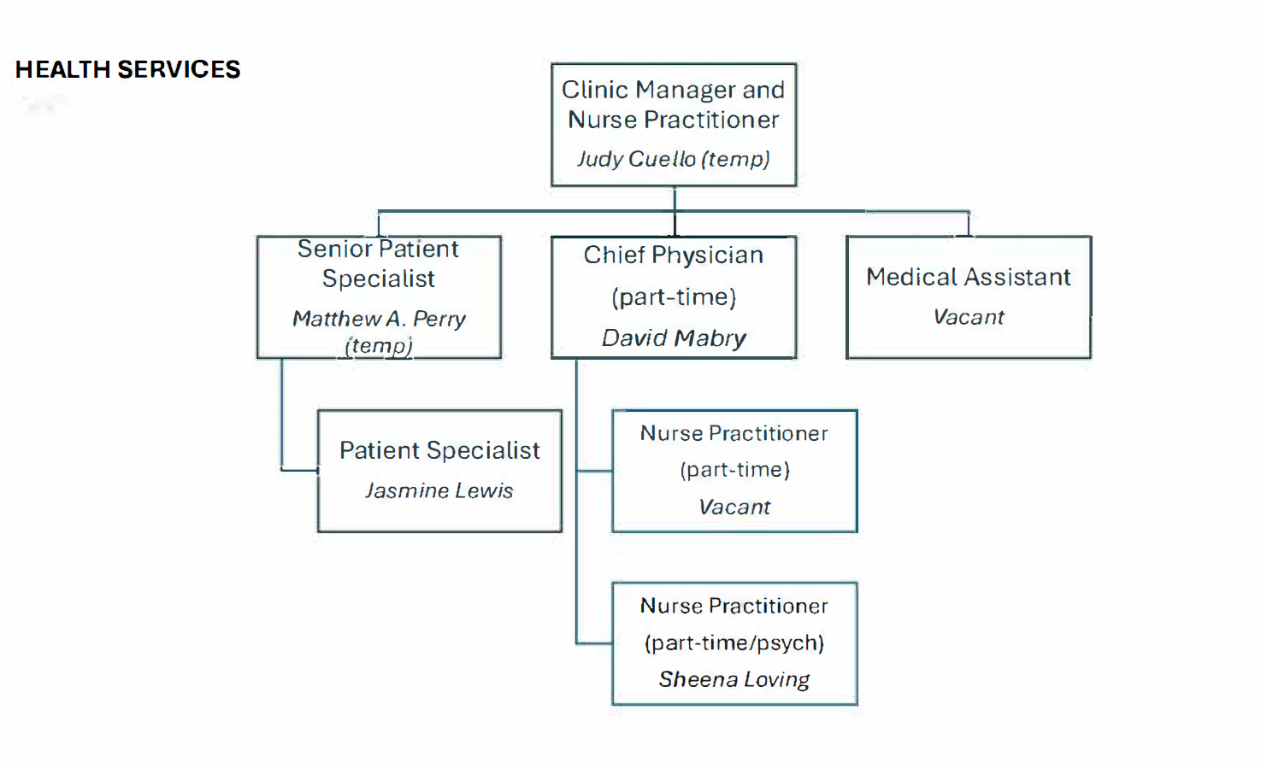

Professional staff shown above; no student staff currently assigned.

Vaccines:
- Heb B
- Flu
- Tetanus (Tdap)
- Meningitis (requesting)

- Present your Budget Worksheet. You are required to show and outline ALL funding sources (i.e. student fees, central funding, grants, gifts, outside sales revenue, auxiliary income, etc.). Use this area to define each funding source, its intended purpose, and how you are utilizing said funds.
  - Attached

- Did you receive any new funding for FY25? If so, please explain how it is being used. If you received any new one-time funding for FY26, please describe your plans to use those funds.
New Funding – FY25 (ending August 31, 2025):
  - $4,400.00 for Medical Supplies and Equipment
  - Original request: $6,037.35, which included funding for a Hyfrecator machine.
  - SFAC approved $4,400.00, designated specifically for general medical supplies and equipment.
  - $8,675.00 for Wellness Exams and Testing
  - Funding provided to support preventive health initiatives, including wellness exams and student testing.
New Funding – FY26 (September 1, 2025 – August 31, 2026):
  - No one-time funding requests were submitted or approved for FY26.
  - For this cycle, there will be a $24,000 request to support psychiatry services, which have recently transitioned to Health Services from the Counseling and Mental Health Center. These services include psychiatric evaluations, ongoing medication management, collaboration with counseling staff for treatment planning, and referrals for higher-level or specialized care when needed.
New Funding – FY27 (September 1, 2026 – August 31, 2027):
- $5,000 – Provider Credentialing Request: Funding is requested to support the credentialing and re-credentialing of contracted and part-time medical providers to ensure compliance with insurance networks, state regulatory requirements, and clinical onboarding standards. This includes application fees, background checks, DEA/NPI verifications, licensing database monitoring, and required documentation processing through credentialing platforms. Centralizing these expenses under Health Services will streamline provider onboarding timelines and prevent service disruptions due to lapsed credentials.

- How does your unit support the mission of Student Affairs and contribute to the student experience on campus? Consider the utilization and impact of your unit’s services.
Support of Student Affairs Mission:
  - The Division of Student Affairs empowers students to thrive academically and personally by fostering wellness, belonging, and student success. Health Services directly supports this mission by removing barriers to care and ensuring students have access to timely, affordable, and comprehensive health services.
Contribution to Student Experience:
  - Accessible Care: A full-time Nurse Practitioner provides daily access to medical care, supported by front-line staff who assist with appointments, insurance activation, and wellness resources.
  - Preventive & Educational Services: Health Services hosts wellness exams, health fairs, gynecology screenings, Blood Drives, and outreach campaigns (HIV/STI awareness, heart health, vaccinations).
  - Expanded Mental Health Services: Beginning in FY26, psychiatry services transitioned from Counseling & Mental Health to Health Services. A new $24,000 funding request ensures students have continued access to psychiatric evaluation and medication management.
  - Student-Centered Affordability: Student funding supports free nursing assessments, free over-the-counter medications, and low-cost lab testing.

- What did you learn in your annual assessment that is impacting your programs and services now?
Annual Assessment Findings:
  - High Utilization Growth: Clinic usage decreased in FY25, with 2034 appointments in FY24. These appointments were migrated into PnC from the previous EHR platform (Titanium), so the dissected data is unavailable.
  - Mental Health Demand: Assessment and student feedback highlighted increased need for psychiatric support, which guided the transition of psychiatry services from CMHC to Health Services in FY26.
  - Preventive Care Engagement: Students expressed interest in more wellness exams, health screenings, and education initiatives, with strong participation in the campus events and resource fairs.
  - Access & Awareness Gaps: Students reported not being fully aware of available services, indicating a need for stronger outreach and communication.
Impact on Programs/Services:
  - Implementing psychiatry services beginning FY26, with a funding request of $24,000 to sustain and expand this offering for FY27.
  - Increasing focus on preventive and wellness care, including free exams, STI testing, and chronic health screenings.
  - Enhancing student communication through targeted outreach campaigns, social media, and collaborations with other Student Affairs units.

- Describe any new programs and/or initiatives for the current year.
Clinical Services Expansion
  - Psychiatry Services Transition: Beginning FY26, psychiatry services transitioned from the Counseling & Mental Health Center to Health Services. This expansion allows students to receive psychiatric evaluations and medication management directly within the clinic, improving continuity of care and reducing wait times.
Preventive Care & Screenings
  - Expand wellness exams and preventive health screenings, including blood pressure checks, cholesterol testing, and cervical cancer screening.
  - Continued focus on HIV/STI awareness and testing, providing confidential, low-cost or free testing services.
Health Education & Outreach
  - Continued partnership with Gulf Coast Regional Blood Center and Center for Student Engagement to host on-campus Blood Drives, providing students an opportunity to give back to the community while also learning about their own health (e.g., free A1C screenings during donation).
  - Expand student wellness campaigns through flyers, tabling, and social media outreach

- What challenges or opportunities do you foresee for the current year and next year?
Challenges
  - Staffing Vacancies: Vacant Registered Nurse and Medical Assistant positions could strain clinic capacity, limiting the ability to meet high student demand.
  - Supply Costs: Rising costs for medical supplies, testing kits, and pharmaceuticals place added pressure on the student fee allocation, requiring ongoing budget adjustments.
  - Awareness & Access: Assessments show that not all students are aware of the free and low-cost services available through Health Services. Increasing visibility remains a challenge.
  - Student Health Insurance Enrollment: Participation in the university-sponsored Student Health Insurance Plan (SHIP) remains low and predominantly with international students, which can limit access to more specialized or off-campus care. Increasing enrollment would strengthen both student outcomes and clinic sustainability. Planned enrollment drivers include coordinated outreach during orientation, email/text reminders near deadlines, partnerships with academic advisors and student orgs, and clear messaging on how SHIP coverage enhances access to primary care, psychiatry, and off-campus specialty services.
Opportunities
- Expanded Preventive & Wellness Services: Building on the success of wellness exams, blood drives, and screenings, Health Services can continue to expand preventive offerings that reduce barriers to academic success.
- Partnerships: Collaborations with Recreation & Wellness, Counseling & Mental Health, Center for Student Engagement, Student Housing, and external partners (e.g., Gulf Coast Regional Blood Center, the Rose, etc.) provide opportunities for broader student engagement.
- Data-Driven Planning: Utilization metrics (See above in Question 1) give Health Services strong evidence to justify continued investment and to tailor services to meet demonstrated student needs.
- Student Worker Development: Peer Health Educator roles offer opportunities to expand health promotion outreach while providing student employees with hands-on experience in healthcare and wellness fields. While the Clinic does not have student workers, utilizing an internship program could help reduce costs and provide educational opportunities.
- Did you have more than $5,000.00 in Student Fee funds swept at the end of FY25? If so, describe how much and in which areas the funds came from.
- Yes. A total of approximately $32,000 in Student Fee funds was swept at the end of FY25.
- These funds were primarily the result of salary savings from temporary vacant, providers, and support staff positions.

- Are you requesting any new one-time funding for FY26 or FY27? Present your budget request with appropriate justification. *Note that only one-time funding requests (no base requests) may be reviewed for FY26 and FY27.
  - For FY26, Health Services requests $8,675 to continue supporting wellness exams and testing.
  - In FY25, $6,300.24 was recorded as used for these initiatives; however, expenses from September to December 2024 were not tracked until 01/01/2025, so the first four months of the fiscal year were not captured in the ledger.
  - To remain compliant with our Point-n-Click (patient scheduling/EHR) contract, we must also plan for annual fees:
  - Year 3 fee (FY27): $22,853.64 – due 07/01/2026
  - Insurance Credentialing (FY27 Request: $5,000): Requested to expand provider network participation and maintain compliance with insurer requirements.

- Please provide a narrative of how your unit would accommodate a reduction of 5.0% in your total FY27 budget and provide a line-item explanation of where budgetary cuts would be made.
Our unit would address a 5.0% reduction in the FY27 budget by focusing on maintaining core clinical operations while scaling back in areas that have less immediate impact on student access to care. The approach prioritizes student health services first and defers growth or enhancements until fiscal conditions improve.
Line-Item Adjustments
- Essential Student Health Services (Protected):
Resources will concentrate on direct care delivery, including physician and counseling services. This ensures students continue to have uninterrupted access to primary and urgent care.
- Outreach, Supplies, and Equipment (–$12,000):
Reduce campus outreach events, limit promotional materials, and restrict supply/equipment orders to only critical items. Non-urgent purchases and replacement cycles will be delayed.
- Staffing (–$18,000):
Delay the planned recruitment of additional RN and MA positions. By holding on these hires, we protect existing core care functions while temporarily slowing service expansion.
Impact Statement
This strategy achieves the required 5.0% reduction while safeguarding essential student health services. Though outreach and hiring will be constrained, the unit will continue meeting compliance standards and maintaining the highest-priority student care functions.

