

MASTER OF ARTS IN BEHAVIOR ANALYSIS

And

CERTIFICATE IN APPLIED BEHAVIOR ANALYSIS

INFORMATION

Revised August 2016

NOTE: Priority Application Deadline for Master’s program: January 5, 2017

What is Applied Behavior Analysis?

Applied behavior analysis is a science aimed at improving socially significant behavior through the application of learning principles, typically at the level of the behavior of the individual rather than of the group. The methods are empirically driven and focus on understanding, predicting, and changing behavior by examining interactions between directly observable behavior and the environment.
Research and practice in applied behavior analysis is wide-ranging, including work in developmental disabilities, behavioral medicine, and education. The effectiveness of behavior analytic interventions, along with the field's focus on accountability in service delivery, has generated a growing demand for professionals with expertise in applied behavior analysis.
Consumers of these services include public and private schools, state agencies, and various other non-profit and for-profit organizations. Most recently, the demand for applied behavior analysts who can provide school- or home-based services for individuals with disabilities, such as autism, has exploded both nationally and locally, as behavioral interventions are now considered the treatment of choice for this population. The demand for Master’s level Board Certified Behavior Analysts (BCBA’s) is now growing at a rapid pace.

Behavior Analysis at UHCL

The goal of the Behavior Analysis M.A. Program is to provide students with a well-rounded foundation in applied behavior analysis through an integrated sequence of coursework, practicum, and research activities.
Students obtain competency in the basic principles of learning and the application of these principles with particular emphasis on interventions for individuals with developmental disabilities. Practicum and research experiences are provided in home, school, and clinic settings. All students complete a major research project prior to graduation.
The program, which is accredited by the Association for Behavior Analysis-International®, includes a course sequence and practicum that have been approved by the Behavior Analyst Certification Board, Inc®. Students completing the coursework and practicum requirements of the program will be eligible to sit for the Board Certified Behavior Analyst (BCBA) exam. The coursework also prepares graduates who are interested in becoming Licensed Psychological Associates. Furthermore, graduates will be prepared to pursue doctoral degrees in psychology or behavior analysis.
The Applied Behavior Analysis Certificate is designed for individuals who have already earned a master’s degree in Psychology or Education and who would like to complete the coursework and practicum required to sit for the Board Certified Behavior Analyst exam.

Program Requirements for M.A. in Behavior Analysis
Prerequisites
Bachelor's Degree or higher, preferably in a related field such as psychology, education, or special education. In addition, applicants should identify coursework or practical experience associated with Behavior Analysis.
Required Courses (36 hours)
PSYC 5235 Learning Principles 3 hours
PSYC 6238 Applied Behavior Analysis 3 hours
PSYC 6338 Ethics and Professional Issues in Behavior Analysis 3 hour
PSYC 6339 Research Methods in Behavior Analysis 3 hours
PSYC 6031 Behavioral Assessment 3 hours
PSYC 6239/6331 Behavioral Intervention 1 and II 6 hours
PSYC 5435 Conceptual Issues in Behavior Analysis 3 hours
PSYC 6134 Biological Bases of Behavior 3 hours
PSYC 5030 Advanced Topics in the Experimental Analysis of Behavior 3 hours
PSYC 6330 Research & Practicum in Applied Behavior Analysis** 6 hours
Select One of the Following Behavior Analysis Electives (3 hours):
PSYC 5736 Behavioral Medicine 3 hours
PSYC 6235 Behavioral/Cognitive Therapies 3 hours
PSYC 5961 Research Topics in Psychology (Behavior Analysis) 3 hours
Select One of the Following Psychology Electives (3 hours):
PSYC 5031 Human Growth and Development 3 hours
PSYC 5131 Psychopathology of Childhood 3 hours
PSYC 5532 Advanced Social Psychology 3 hours
PSYC 6832 Advanced Cognitive Psychology 3 hours

**Research and field experience under the supervision of a BCBA/UHCL faculty member in home, school, or clinic settings. Requires completion of a research project and 20 hours per week of field experience in home, school, or clinic settings for two semesters (3 credits per semester).

Sample Schedule (M.A. Program)
- Fall Year 1: Learning, Applied Behavior Analysis, Ethics
- Spring Year 1: Behavioral Assessment, Research Methods, Bio Basis
- Fall Year 2: Behavioral Interventions I, Conceptual Issues, Psych or BA Elective
- Spring Year 2: Behavioral Interventions II, Psych or BA Elective
- Fall and Spring Year 3: Advanced Topics in EAB; Research & Practicum

ABA Certificate-Only Program
Prerequisites
Applicants must have a Master's Degree in behavior analysis, psychology, education, or special education from an accredited university.
Students enrolled in the ABA Certificate Program complete the following (27 hours):
PSYC 5235 Learning Principles 3 hours
PSYC 6238 Applied Behavior Analysis 3 hours
PSYC 6338 Ethics and Professional Issues in Behavior Analysis 3 hour
PSYC 6339 Research Methods in Behavior Analysis 3 hours
PSYC 6031 Behavioral Assessment 3 hours
PSYC 6239/6331 Behavioral Interventions 1 and II* 6 hours
PSYC 6330 Research & Practicum in Applied Behavior Analysis** 6 hours
*This seminar course covers specialized applications of behavior analytic principles and methods, and includes class meetings and up to 10 hours per week of field activities in home, school, and clinic settings. This course is taken for two semesters (3 credits per semester).
**Research and field experience under the supervision of a BCBA/UHCL faculty member in home, school, or clinic settings. Requires completion of a research project and 20 hours per week of field experience in home, school, or clinic settings for two semesters (3 credits per semester).

ABA Faculty
Full Time Faculty
Fritz, Jennifer N., Associate Professor (Ph.D., BCBA-D; University of Florida – 2008)
Assessment, treatment, and prevention of severe behavior disorders; autism and developmental disabilities; and caregiver training
Lechago, Sarah A., Associate Professor (Ph.D., BCBA-D Western Michigan University – 2009)
Verbal behavior, motivating operations, treatment of autism and other developmental disabilities, social skills training
Lerman, Dorothea C., Professor (Ph.D., BCBA-D, University of Florida – 1995)
Autism and developmental disabilities, functional analysis, treatment of severe behavior disorders, and parent and teacher training
Short, Mary B., Professor (Ph.D., Western Michigan University)
Pediatrics, behavioral medicine, women’s health

Applying to the Program

Students wishing to enroll in the Behavior Analysis Program or ABA Certificate Program must formally apply. Applications to the M.A. program are accepted for the Fall semester only. Applications for the Certificate-Only program are accepted for the Fall and Spring semesters. Additional information can be obtained by contacting the faculty coordinator, Dorothea Lerman (281-283-3437; behavioranalysis@uhcl.edu).
Application requires both Steps 1 and 2 below be completed.
Step 1: Apply for admission to the University of Houston-Clear Lake:
- Complete the “ApplyTexas” on-line university application. Currently there is a fee for the university admission application. Go to www.uhcl.edu. Select the “Admissions” tab, and click on “Apply Now” near the top of the page. Once you create a profile, you will complete the application. Select U.S. Graduate Application. If applying to the master’s program, select HSH-Behavior Analysis MA as your major. If applying to the certificate program, select HSH-Applied Behavior Analysis Certificate. The university application should be completed as early as possible before the admissions deadline to allow adequate time for the Office of Admissions to process the application and evaluate transcripts.
- Submit GRE scores (not more than 5 years old) through the standard reporting procedures (Not required for Certificate-Only applicants)
- Submit official transcripts from all institutions attended. Transcripts should be mailed to this address:
Office of Admissions
University of Houston-Clear Lake
2700 Bay Area Blvd.
Box 13
Houston, TX 77058

Step 2: Submit Additional Supporting Documents for the Behavior Analysis Program
- You will be assigned a UHCL account after you have completed the ApplyTexas (university on-line application). You will receive an e-mail with instructions on how to access your account. The following supporting documents must be uploaded within your account (see additional, detailed instructions at the end of this packet):
- Curriculum Vitae: An expanded résumé describing previous education; all work experience; relevant course work and relevant volunteer activities; any honors, presentations, papers, avocations or other relevant life experiences
  - Statement of purpose and goals, not to exceed 1,000 words, describing your reasons for wanting this degree and how it fits into career goals.

- Two letters of recommendation, preferably at least one from an academic source, should be submitted directly by the recommenders to behavioranalysis@uhcl.edu. No form is required. Recommendations from academic faculty and/or work supervisors who know the applicant well are especially solicited.
Deadline for Application:
For the M.A. Program, review of applications for Fall admission will begin on January 5th. Applications submitted after this date will be reviewed on a case-by-case basis. Applications to the ABA Certificate-Only Program must be submitted by March 1st to receive consideration for the Fall semester and October 1st to receive consideration for the Spring semester. It is the applicant’s responsibility to ensure that his/her application for university admission and supporting transcripts are received by the university Office of Admissions, that all additional supporting documents have been uploaded, and that letters of recommendation are submitted directly by the references. All applicants can check the status of their application by logging into their accounts.
Required Application Materials Checklist:
_____ ApplyTexas University Application
_____ Transcripts
_____ GRE scores (M.A. Applicants Only)
_____ Curriculum Vitae
_____ Statement of Purpose/Goals
_____ Two Letters of Recommendation

Additional information regarding applications:
Any evidence of tampering with recommendations or transcripts could result in disqualifying the applicant from admission. Applicants should note that admission to graduate status at the university is not equivalent to admission to the Behavior Analysis Program or ABA Certificate Program. Applicants are not admitted into the Behavior Analysis M.A. Program or Certificate Program until they receive formal notice from the Behavior Analysis Admissions Committee that they have been accepted.
Uploading Supporting Documents
Steps | Illustrations
- Go to www.uhcl.edu/eservices and login using your 7 digit user ID and password to access E-Services. | 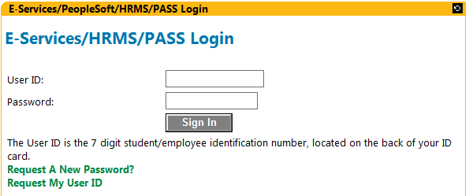
- Click on the UHCL E-Services link. | 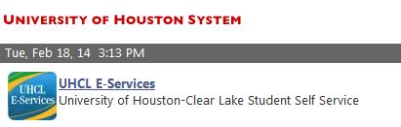
- Click on the Student Center link under Learner Services. | 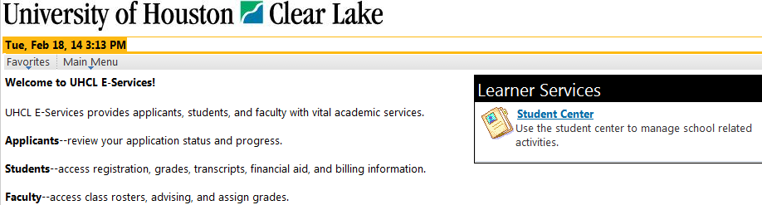
- Under your To-Do List, click on Details/Upload Documentation link. | 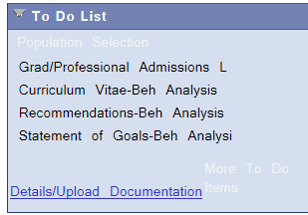
- To upload a document, click on the Upload/View Document link under the Details/Upload Document column. | 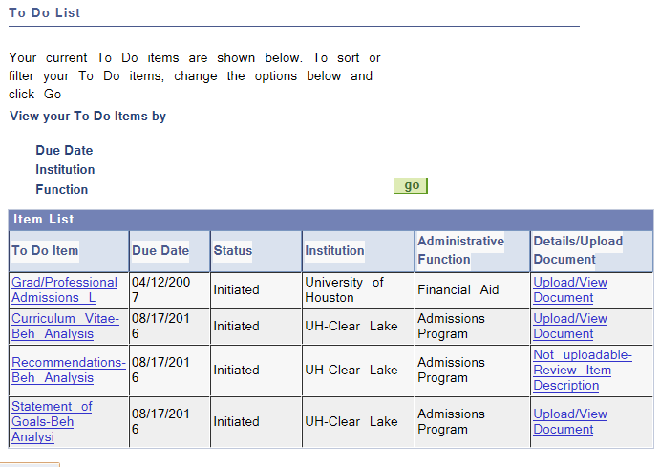
- Click on the Upload File button | 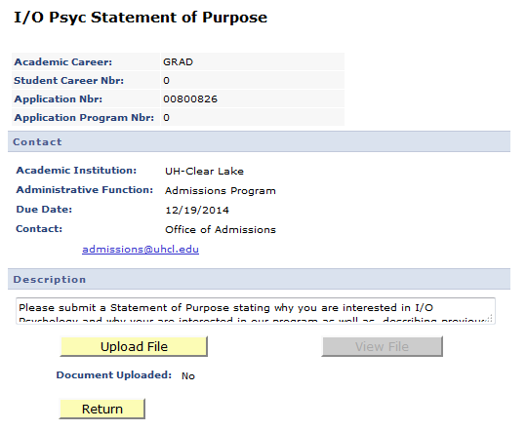
- The system will provide a message to indicate that the file naming conventions and format required. It will also provide you a statement asking for certification of information provided.  - Click OK | 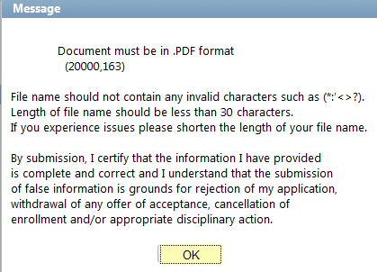
- Click on Browse to find file.  - Select file from your computer and click on upload. | 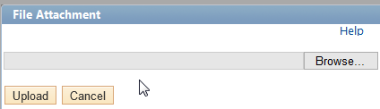  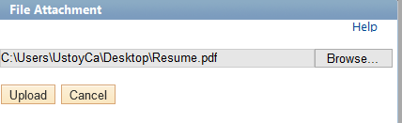
- Once the document has successfully uploaded, the system will show View File and Document Uploaded will show Yes.  - Click on Return. | 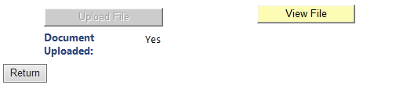
- Once you have completed uploading your documents, you can return to the Student Center to view any remaining to do items. | 