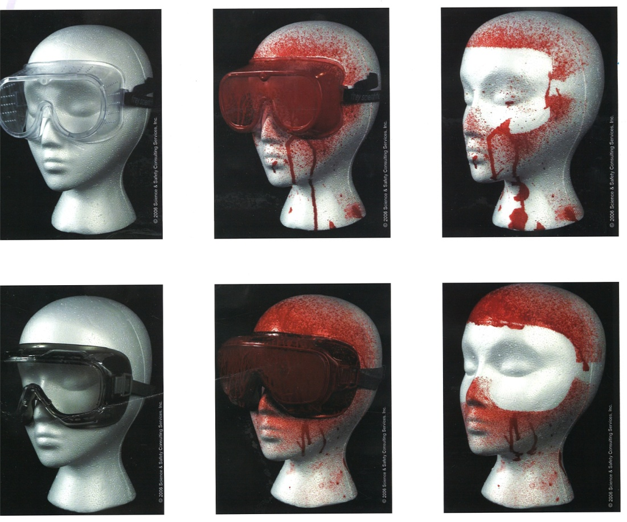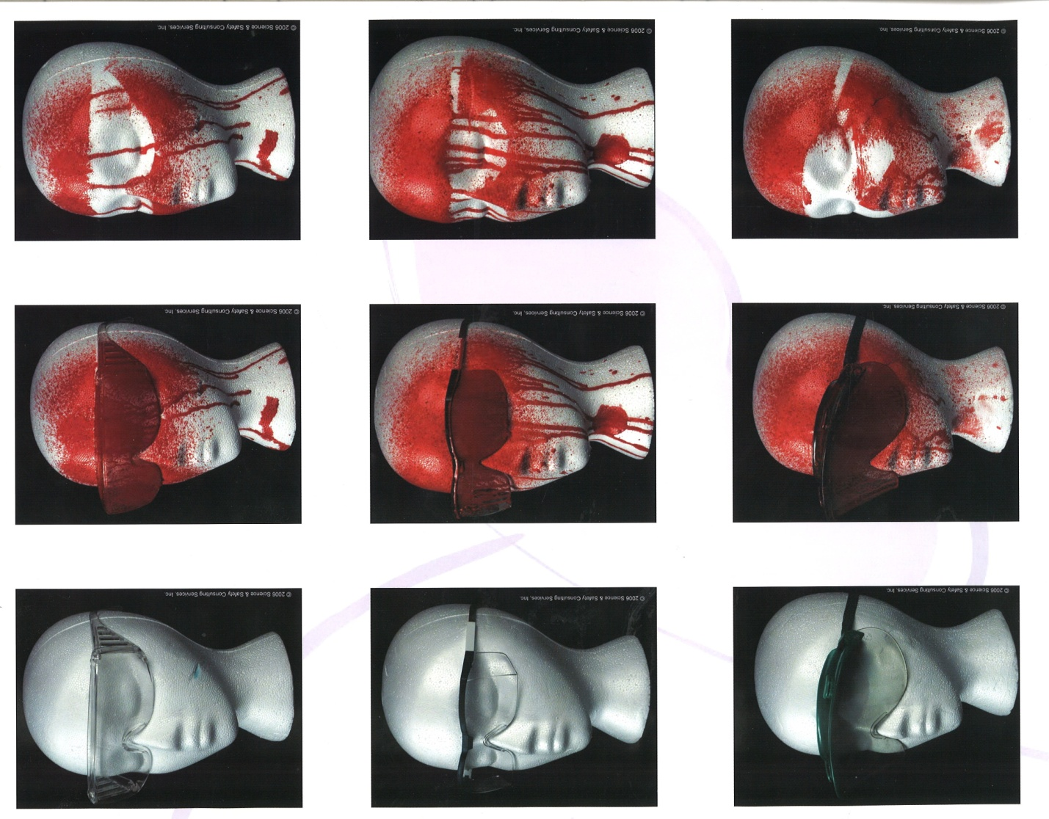**Protective Eyewear and Chemical Splash Protection**

These pictures illustrate the amount of protection different eyewear provide. None of the safety glasses pictured here protect the eyes from drips or side spray in the event of a splash to the face. Safety goggles provide the most protection, if the goggles are indirectly vented. Direct vent pinholes still allow chemicals to splash into the eyes.