**How to Self-enroll in** **EHS Training Workgroups at UHCL**

This tutorial will demonstrate how to add yourself as a student to any of the EHS Training Workgroups. **NOTE: Self-enroll is NOT used for any "regular" credit courses.**

1. Begin by going to Go.UHCL.edu and logging in with your UHCL credentials.

1. After logging in, click on the Blackboard card.

1. Once you are on the main page in Blackboard, click one of the following links, or paste the correct one into the address bar of your browser and press the Enter key on the same browser tab you are currently on:
   * Animal Care Training: <https://uhcl.blackboard.com/ultra/courses/_14390_1/cl/outline>
   * Employee EHS Training: <https://uhcl.blackboard.com/ultra/courses/_13475_1/cl/outline>
   * Student Lab Safety Training: <https://uhcl.blackboard.com/ultra/courses/_13477_1/cl/outline>
   * Advanced Lab Safety Training (for TA’s, RA’s, Grad Student Independent Studies, employees): <https://uhcl.blackboard.com/ultra/courses/_13476_1/cl/outline>

**\*Screenshots from the Animal Care Training are used from this point forward, but you should see the same or similar screens for each training\***

1. After clicking the link or pasting it into your browser address bar and pressing the Enter key, you should see a page that says “User is not enrolled in course” at the top. Below that you will see some text that includes a link. Click the “Click here to enroll.” link.

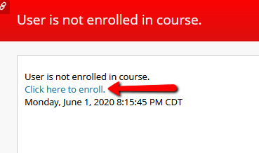

1. After clicking “Click here to enroll.”, you will be taken to what looks like a course page, but will be told you don’t have access. On the left side where the Course menu would normally be, you will see a button with a plus sign that says Enroll. Click Enroll.

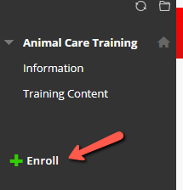

1. After clicking enroll, you will be taken to the Self Enrollment page. Confirm that it says you are enrolling in the training course you have chosen. Click Submit.

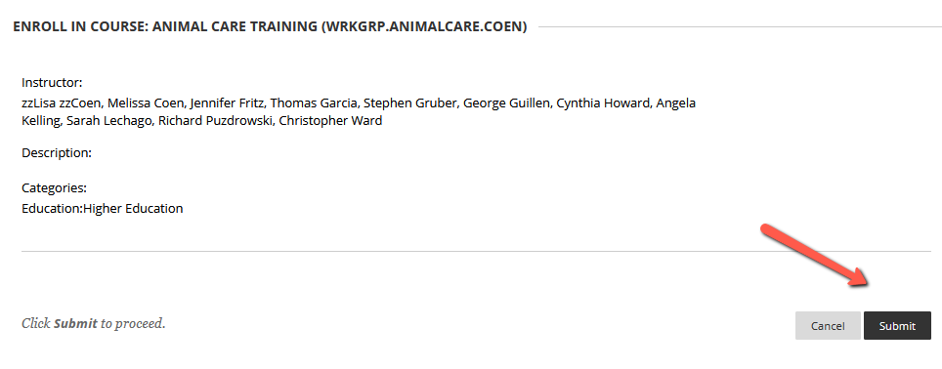

1. After clicking Submit, you should see a Success message with an OK button. Click OK to be taken back to the training course you have enrolled in.

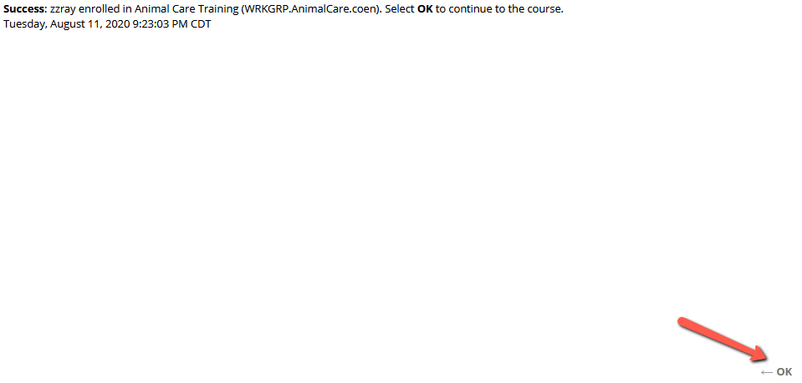

1. You will then be logged into the course and can begin.

