SPILL PREVENTION, CONTROL AND COUNTERMEASURE
QUICK REFERENCE GUIDE

CONTINGENCY MEASURES FOR
RELEASE OF OIL

UNIVERSITY OF HOUSTON – CLEAR LAKE
2700 BAY AREA BLVD
HOUSTON, TEXAS 77058

March 2019

40 CFR 112.7(a)(3)(iv) – Address Countermeasures for discharge discovery, response, and cleanup (both the facility's capability and those that might be required of a contractor);

40 CFR 112.7(a)(3)(v) – Address methods of disposal of recovered materials in accordance with applicable legal requirements;

40 CFR 112.7(a)(3)(vi) – Provide contact list and phone numbers for the facility response coordinator, National Response Center, cleanup contractors with whom you have an agreement for response, and all appropriate Federal, State, and local agencies who must be contacted in case of a discharge as described in 40 CFR 112.1(b).

40 CFR 112.7(a)(5) – Organize portions of the Plan describing procedures you will use when a discharge occurs in a way that will make them readily usable in an emergency, and include appropriate supporting material.

This Quick Reference Guide (QRG) provides the steps the University of Houston - Clear Lake (UHCL) personnel take in the event of a release of oil at the UHCL campus. Persons should refer to the campus Spill Prevention Control and Countermeasure Plan for specific information regarding oils stored, oil volumes, and spill prevention measures.

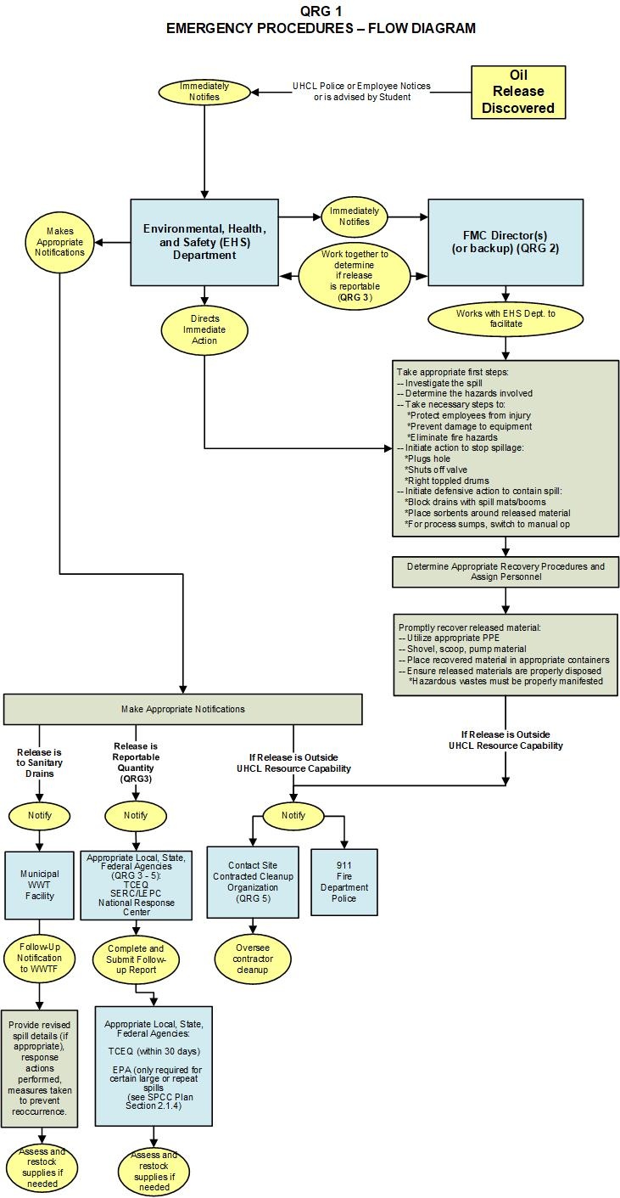
QRG-2
CAMPUS CONTACTS
Environmental, Health and Safety (EHS) Contacts
In the event of any release of oil, the person who notices the spill must immediately notify the Director of Emergency Management and Fire Safety, the designated person responsible for spill control (or his backup/alternate):
Al Black, Director of Emergency Management and Fire Safety  (Primary contact) | UHCL phone: 281-283-2110  Cell (24-hr contact): 346-208-6519
Niki Pearce, EHS Coordinator  (Alternate contact) | UHCL phone: 281-283-2109  Cell (24-hr contact): 713-922-1178
Lisa Coen, EHS Coordinator  (Alternate contact) | UHCL phone: 281-283-2107  Cell (24-hr contact): 832-260-6975
Hank Grotewold, EHS Coordinator  (Alternate contact) | UHCL phone: 281-283-2104  Cell (24-hr contact): 281-889-9146
The Director of Emergency Management and Fire Safety along with the Environmental, Health and Safety (EHS) Coordinators act as a technical resource to the Director of Facilities Management and Construction (FMC) and FMC personnel during response actions, and are responsible for determining if the UCHL personnel are capable of responding to the release, conducting the actual response, determining if the release requires reporting to any required Federal, State or Local government agency, and making such reports.
Facilities Management and Construction (FMC) Contacts
FMC is responsible for maintaining all oil storage facilities, generators, elevators, and transformers, or the contracts associated with them. The Associate Vice President (AVP) of FMC will be notified for all releases, along with the FMC personnel responsible for the respective equipment where the release occurred.
Eric Herrera, AVP of FMC | UHCL phone: 281-283-2250  Cell (24-hr contact): 832-455-5743

Municipal Wastewater Treatment Contact
In the event of a release of oil to the facility’s sanitary drains that discharge to the local publicly owned treatment facilities, the EHS Department will contact the treatment facility.
Clear Lake Water Authority  900 Bay Area Blvd  Houston, TX 77058 | Phone (24-hr): 281-488-1164  Fax: 281-488-3400

QRG-3

Regulatory Agency Immediate Notification Requirements
Agency Contacts and Reportable Quantities [40 CFR 112.7(a)(3)]
In the event of a release of a hazardous material, immediate notification to local, state, and federal agencies are required under certain circumstances.
AGENCY | PHONE NUMBER | WHEN
OIL RELEASED ABOVE REPORTABLE QUANTITIES (RQ):
To satisfy Texas requirements, one of the following:
TCEQ Spill Reporting (24-Hour) | 800-832-8224 | Upon the determination that a RQ spill has occurred, notify TCEQ as soon as possible but not later than 24 hours after discovery.
TCEQ Region 12 Office | 713-767-3500 (Houston)
State Emergency Response Center (SERC) | 800-832-8224
To satisfy National/Federal Requirements for RQ release of Oil:
National Response Center | 800-424-8802 | Upon the determination that a RQ spill to water has occurred, notify NRC as soon as possible but not later than 24 hours after discovery.
RELEASES CREATING AN IMMINENT THREAT, FIRE, AND HAZARDOUS MATERIALS:
Fire Department | 911 | If the discharge or spill creates an imminent health threat, immediately notify and cooperate with local emergency authorities
Police Department | 911
Southeast Regional LEPC | 911  713-475-4996
OTHER LOCAL REQUIRED RELEASE NOTIFICATION
Harris County Pollution Control Services, Emergency Response Services Section Harris County Pollution Control Service Department | 713-920-2831 (24-hr spill phone)  713-274-6356 (non-emergencies)  713-274-6300 (main)  713-274-6475 (fax) | All oil discharges or spills
City of Houston Water Quality Control – Bureau of Public Health Engineering (BPHE) | 713-920-2831 (HCPHES, see above) | All oil discharges or spills to the storm sewer from the Arbor or Delta Buildings
(continued on next page)

OTHER LOCAL REQUIRED RELEASE NOTIFICATION (continued)
City of Pasadena Office of Emergency Management | 911  713-475-7800 (24-hr dispatcher)  713-475-5588 (main) | All oil discharges or spills to the storm sewer from the Bayou/SSCB/FMC/NOA Buildings
Clear Lake Water Authority | 281-488-1164 (24 –hr) | All oil discharges or spills to the sanitary sewer system

Determining Reportable Quantities:
TCEQ and NRC Spill Notification
Oil Spills onto Land:
- 25 gallons or more of used oil or petroleum products,
- 210 gallons or more of crude oil, unused (new) oil, or oil that is not a petroleum product

Oil Spills into Waters of the State or Navigable Waters of the U.S.:
- Discharges that cause a sheen or discoloration on the surface of a body of water;
- Discharges that violate applicable water quality standards; and
- Discharges that cause a sludge or emulsion to be deposited beneath the surface of the water or on adjoining shorelines.

QRG-4 provides a list of the information to report to State and Federal agencies.
QRG-4
State and Federal Regulatory Agency Spill Reporting Information Requirements
[40 CFR 112.7(a)(4) and 30 TAC 327]
In the event a release is required to be reported, copy this page, and be prepared to provide agency the following information:
- Address/location of the facility: 2700 Bay Area Blvd, Houston, Texas 77058
- Phone number of the facility:
- Date and time of the discharge:
- Type of material discharged:
- Estimates of the total quantity discharged:
- Estimates of the quantity discharged to navigable waters or adjoining shorelines:
- The source of the discharge:
- Description of all affected media:
- Cause of the discharge:
- Any damages or injuries caused by the discharge:
- Actions being used to stop, remove, and mitigate the effects of the discharge:

- Whether an evacuation is needed:
- Names of individuals and/or organizations who have also been contacted:

- A description of the extent of actual or potential water pollution or harmful impacts to the environment and an identification of any environmentally sensitive areas or natural resources at risk:

- Any known or anticipated health risks:
IMPORTANT:
Record the information you provided to the agency in the blanks, above. Use more pages if necessary.
Also record the following:

Agency Contacted: _____________________________ Case No: ________________________________
Any additional information: __________________________________________________________________

QRG-5
CAMPUS CLEANUP CONTRACTORS [40 CFR 112.7(a)(3)]
In the event UHCL determines that an oil release exceeds UHCL’s resources for cleanup, the following cleanup organizations will be contacted as appropriate:
Contractor Name: | Veolia North America
Phone Number: | 281-427-4099 (non-emergency)  281-739-0514 (Danny Bragg)
Addresses: | 1800 S Hwy 146  Baytown, TX 77520
Contractor Resources: | Trained response personnel  Containment materials  Absorbent materials  Drums/Totes/rolloff and vacuum boxes, vacuum trucks  Vehicles for hauling contaminated material
Contractor Name: | Garner Environmental Services
Phone Number: | 800-424-1716
Addresses: | 1717 W. 13th Street  Deer Park, TX, 77536
Contractor Resources: | Trained response personnel  Containment materials  Absorbent materials  Drums/Totes  Vehicles for hauling contaminated material  A full listing of Garner resources is available on their website: http://garner-es.com
Contractor Name: | Allied International Emergency, LLC
Phone Number: | 817-595-0100 (24-hr) or  800-980-7911 (24-hr))  817-595-0125 (fax)
Addresses: | 2416 Gravel Drive  Fort Worth, TX 76118
Contractor Resources: | Trained response personnel  Containment materials  Absorbent materials  Drums/Totes  Vehicles for hauling contaminated material
Contractor Name: | Eagle Construction & Environmental Services, LP
Phone Number: | 800-336-0909 (24-hr)  281-867-9131 (non-emergency)
Addresses: | 1700 North E Street  La Porte, TX 77571
Contractor Resources: | Trained response personnel  Containment materials  Absorbent materials  Drums/Totes  Vehicles for hauling contaminated material

The 24-hour Spill Reporting line is supported by several Texas agencies and is answered 24 hours a day. It serves as the TCEQ spill reporting line during the day and the State Emergency Response Commission (SERC) line at night.
The NRC is the sole federal point of contact for reporting all spills to water, or releases of hazardous materials exceeding their reportable quantity.
Petroleum product – In Texas, a petroleum product is defined as a petroleum substance obtained from distilling and processing crude oil that is liquid at standard conditions of temperature and pressure, and that is capable of being used as a fuel for the propulsion of a motor vehicle or aircraft, including but not necessarily limited to motor gasoline, gasohol, other alcohol blended fuels, aviation gasoline, kerosene, distillate fuel oil, and #1 and #2 diesel. The term does not include naphtha-type jet fuel, kerosene-type jet fuel, or a petroleum product destined for use in chemical manufacturing or feedstock of that manufacturing. 30 TAC 327.2

