Step 1 Login into your student portal.

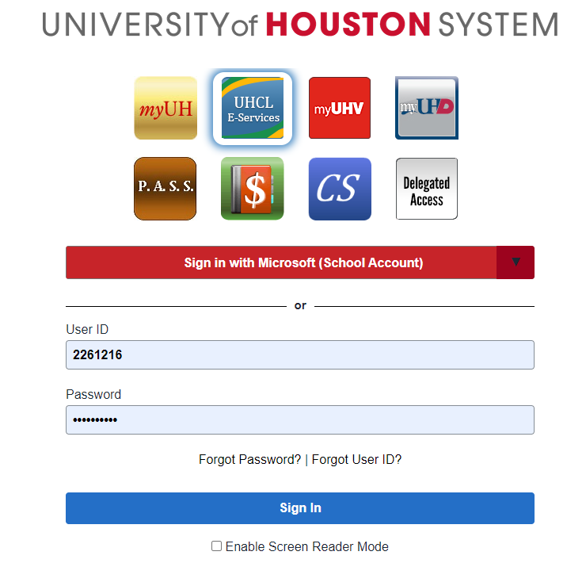

Step 2 Click on the “Finances” tab on your Student Homepage

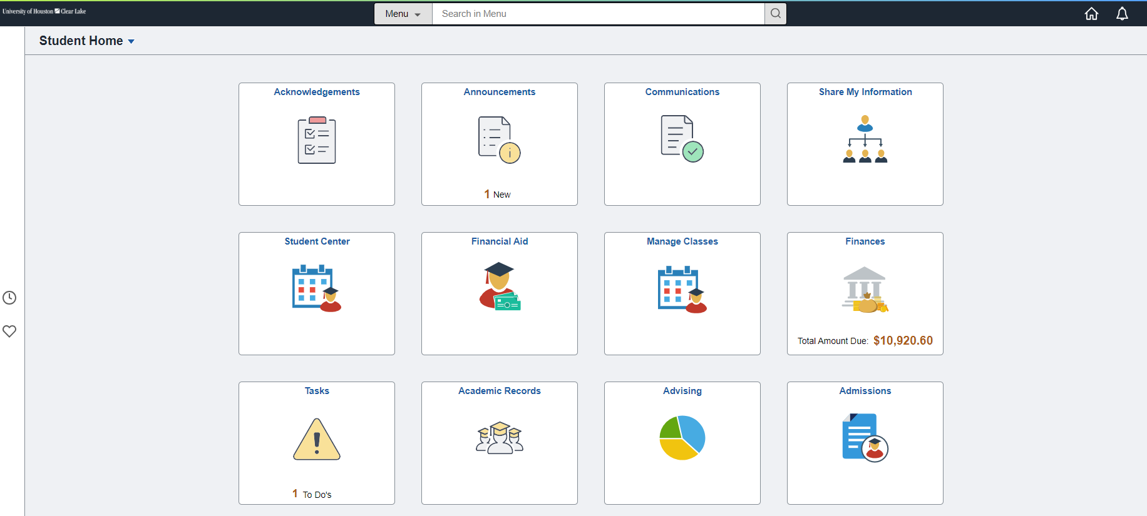

Step 3 The Student Financials Collection page will load. From here click the “Make a Payment” link on the left-hand side of the page.

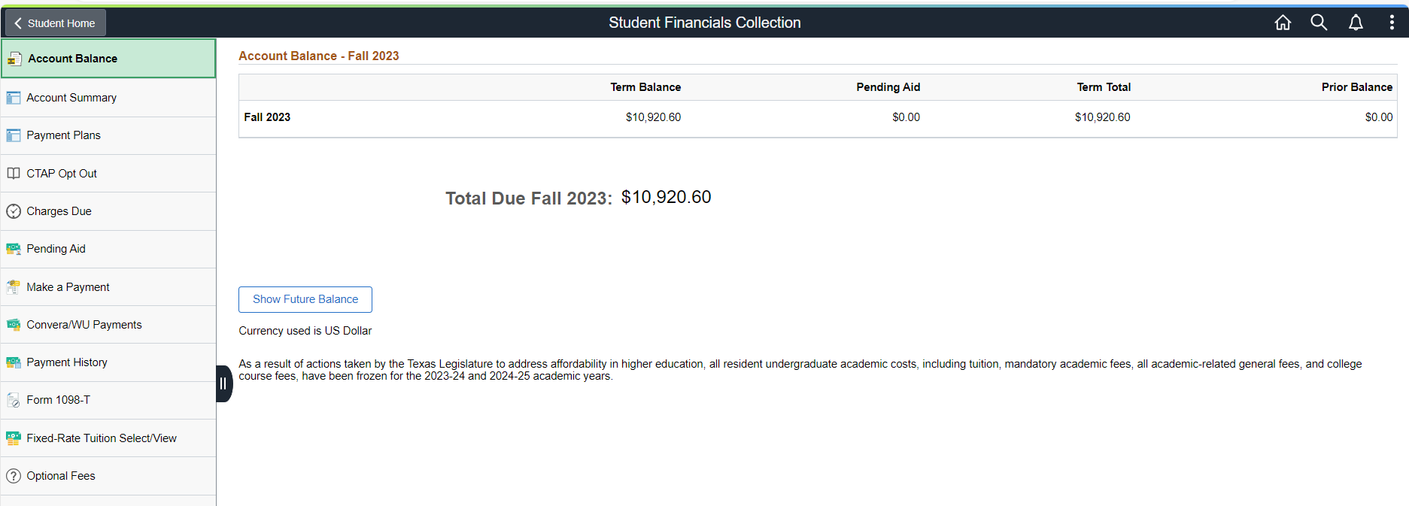

Step 4 The Make a Payment page will load. Input the amount of your payment in the “Payment Amount” box.
Step 5 Then under the “How to Pay” heading, click the down arrow next to “Pay By” and choose your payment method.
Step 6 Read and agree to the Terms and Conditions
Step 7 Click “Submit”.

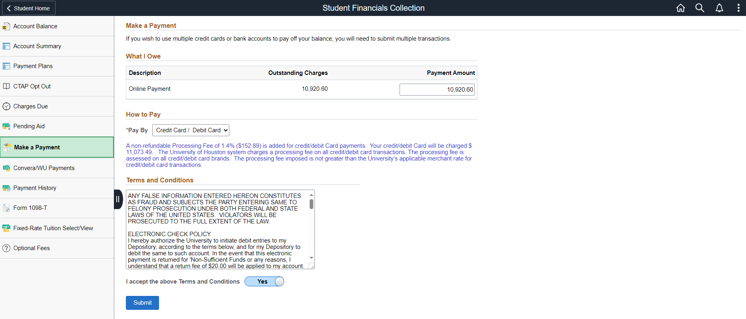

Step 8 Enter your payment information and all the required fields.

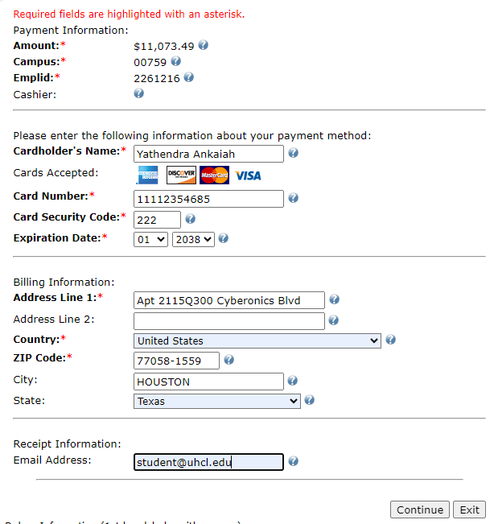

Step 9 Click “Continue”.

Step 10 Once you see that your payment was successful and a confirmation screen, you’re done.

